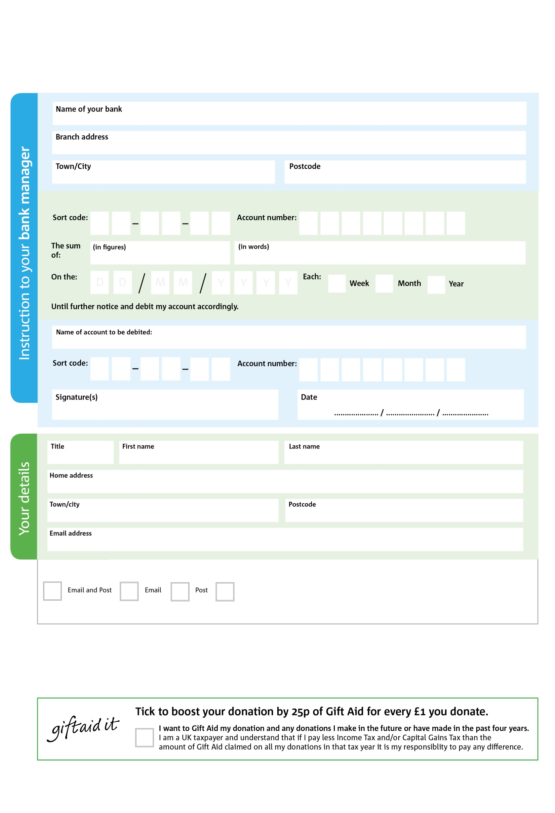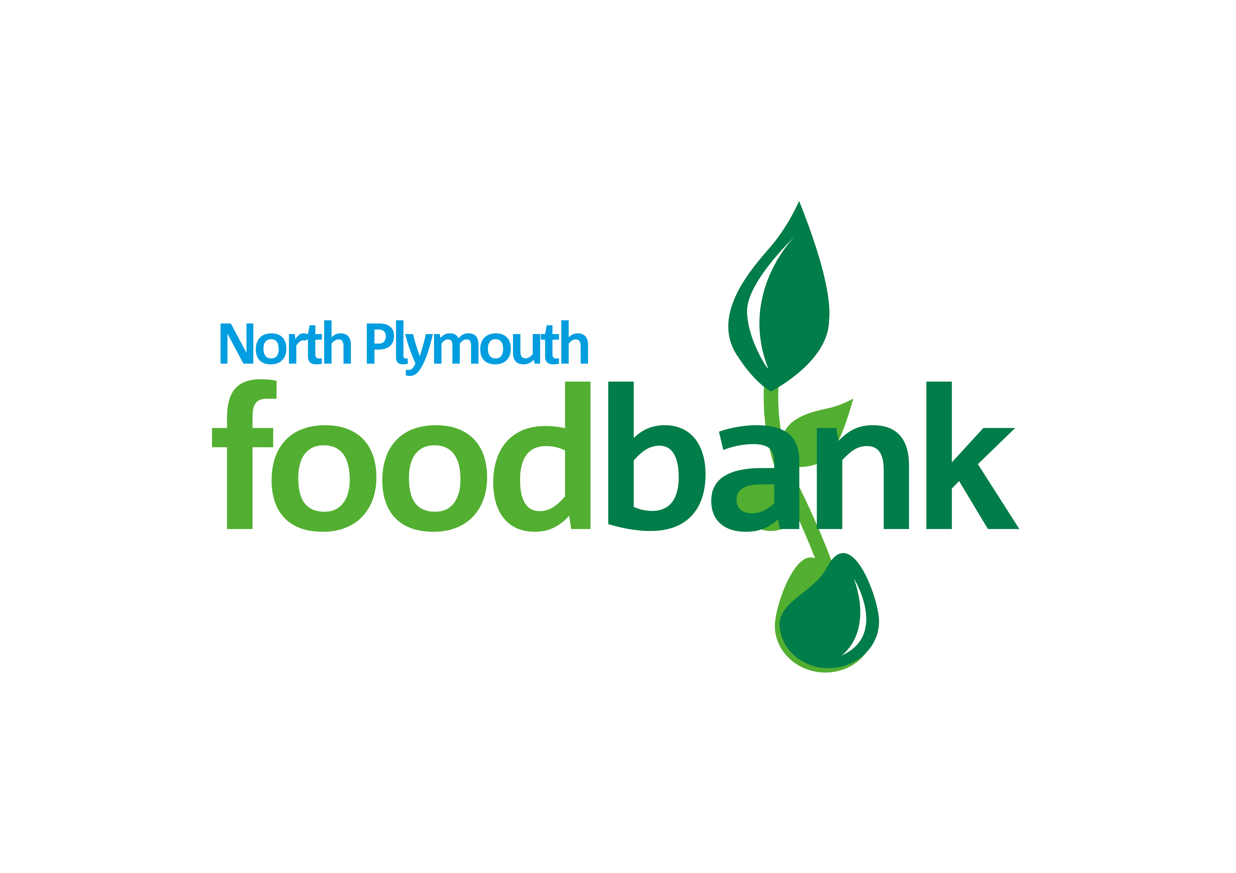

**Data protection:** *North Plymouth Foodbank is committed to protecting your privacy and will process your personal data in accordance with current Data Protection legislation. North Plymouth Foodbank collects information to keep in touch with you and supply you with information relating to our work. To unsubscribe from our newsletter, send a message to the email address above with the word unsubscribe in the subject line. A full data privacy statement for financial donors is available from the foodbank on request.*

I do not wish to receive future communications from North Plymouth Foodbank

9999

0X0

6

V

3

V

1X

V

8

V

7

7

3X

V

3

V

3

V

7

V

9

1

Please pay: North Plymouth Community Church (Ref: Foodbank) **Foodbank)**

**POSTAL ADDRESS: North Plymouth Foodbank, North Plymouth Community Church, Plymbridge Rd, Estover, Plymouth, PL6 7LF**

**A project of North Plymouth Community Church, Registered Charity No: 1050309, Reg in England & Wales**

**Please pass this form onto the foodbank, using the foodbank’s address at the bottom, who will save a copy for their records.   
They will then send it onto your named bank or building society. If you use online banking to set up please quote Ref: Foodbank**

We would love to keep you up to date with information about North Plymouth Foodbank. Please tick your preference:

**You can change your preferences any time by emailing us at: info@northplymouth.foodbank.org.uk**

**Standing Order Mandate**

**northplymouth.foodbank.org.uk**

You can change your preferences any time by contacting us on XXXXXXXXXXX or emailing us at XXXX@XXXXXXXXXX.foodbank.org.uk

I do not wish to receive future communications from XXXXXX Foodbank